Context
Companies use servers of all types, and an Information Technology Professional is expected to be able to setup, optimize, and maintain servers of various operating systems and functions.
For this project, you have been tasked with setting up a web server to host a small website. A single server has been allocated for this use, which you will simulate using Oracle VirtualBox. You may choose to use any version of Windows server, or any distribution of Linux as your operating system. All other required software will be chosen using open source or trial versions for setting up the actual server instance. The web developer will provide you with the website files in a .zip file to load on the server in the Final Project Draft assignment.
This assignment will be done in phases.
- Week 9: Final Project Part 1 - Proposal
  - You will submit your proposal with your choice of operating system and a list of open-source or trial software that you will be installing to make the web server operational. This will include the justification for your choices.
- Week 11: Final Project Part 2 - Draft
  - You will submit screenshots of the operational web server administrative screens and output, based on feedback received on the proposal.
- Week 14: Final Project Part 3 - Submission
  - You will submit the updated documents from weeks 9 and 11 and a three- to five-minute video describing the installation, optimization, and current operation of the web server that was simulated with Oracle VirtualBox.
Steps
For this assignment: Final Project Part 3, you will need to utilize the feedback you received from your instructor for Weeks 9 and 11 assignments.
- Utilizing the feedback from your proposal and draft assignments, update your operating system and software list as required. Save that document in DOCX or PDF format.
- Utilizing the feedback from your draft assignment, update or modify your web server instance as required. Retake the screenshots required for the draft assignment and save the compiled document in DOCX or PDF format.
My Ubuntu Server

Software | Version | Type | Purpose
Apache HTTP Server | 2.4x | Open Source | Handles HTTP requests and presents pages to viewers
MySQL Server | 8.0 | Open Source | Database management to store website data
PHP | 8.1 | Open Source | Scripting language for making web pages (server-side)
phpMyAdmin | 5.2 | Open Source | Interface for managing MySQL Databases
OpenSSH | 10.2 | Open Source | Allows remote access and management of the server
Vim | 9.2 | Open Source | Command line text editor. (Nano also could work but I prefer Vim)
Git | 2.53.0 | Open Source | Version control system for managing and pushing website code
Fail2Ban | 1.1.0 | Open Source | Log management while also banning suspicious IPs
Cerbot | 5.4.0 | Open Source | Allows free SSL/TLS certificates for HTTPS encryption
Nginx | 1.29.2 | Open Source | Better performance, load handling, and static file delivery in front of Apache.
UFW firewall | 26.04 | Open source | Simple firewall management and making controlling ports much easier
Redis | 8.4.2 | Open Source | Acts as a database or application cache

Apache server status
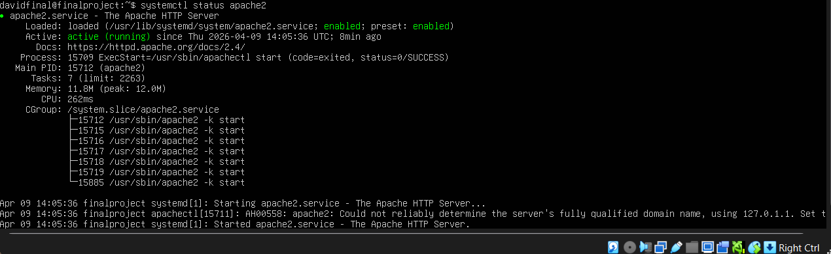

SSH
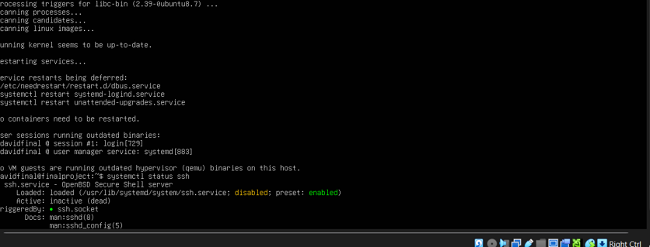
(Git, Vim, Fail2bam and Certbot) installation
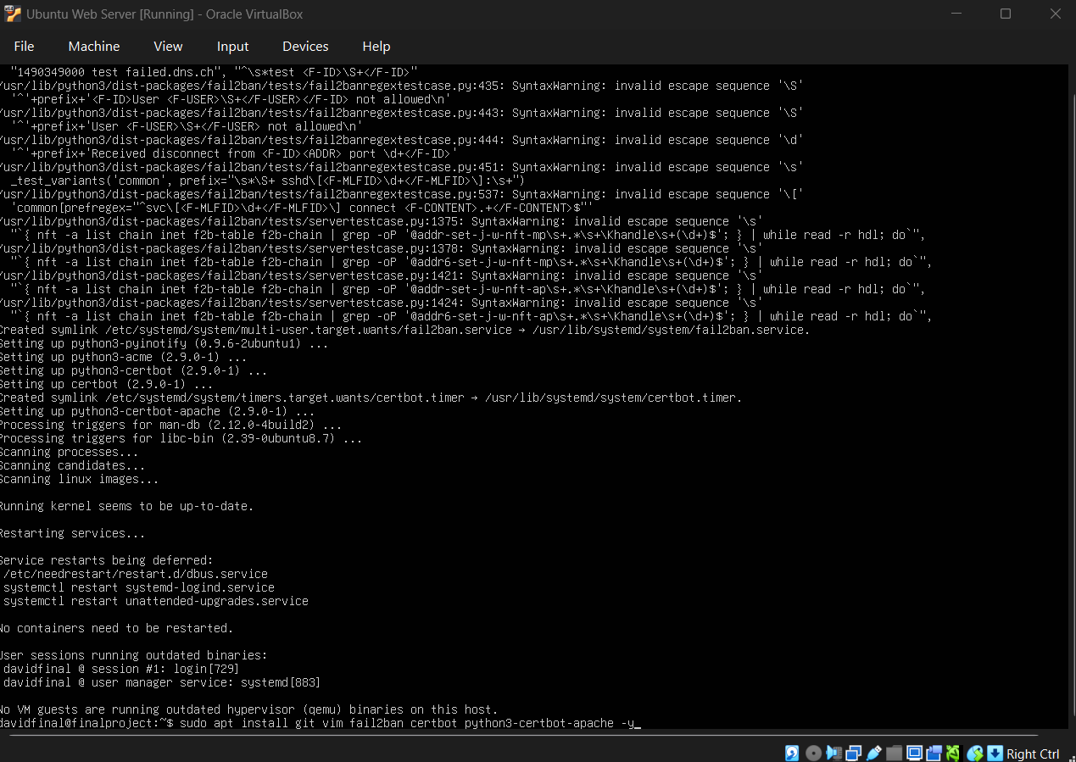
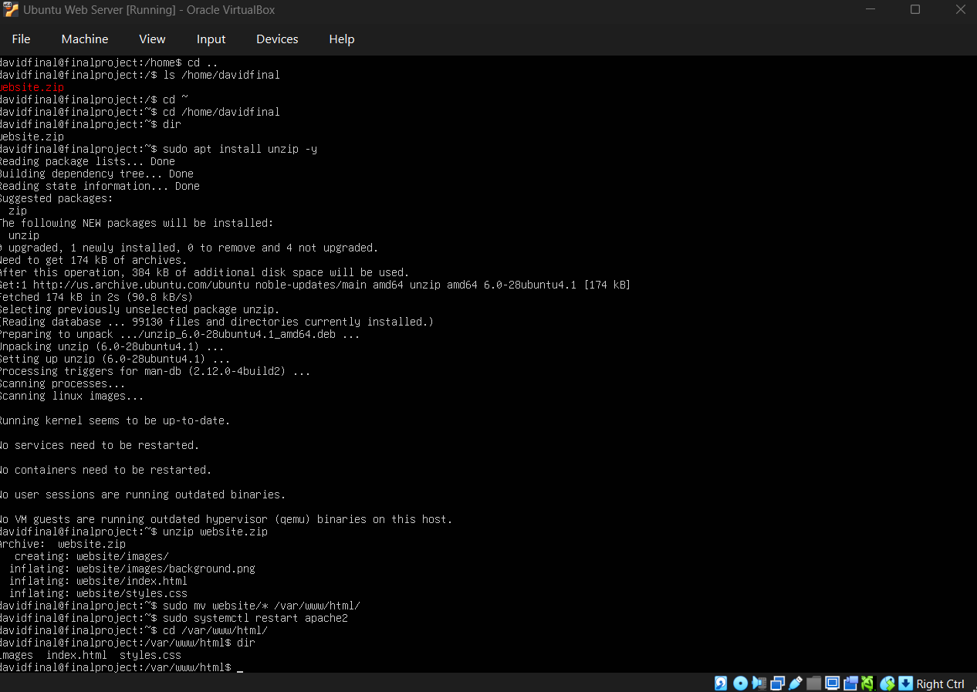
Nginx install and status:
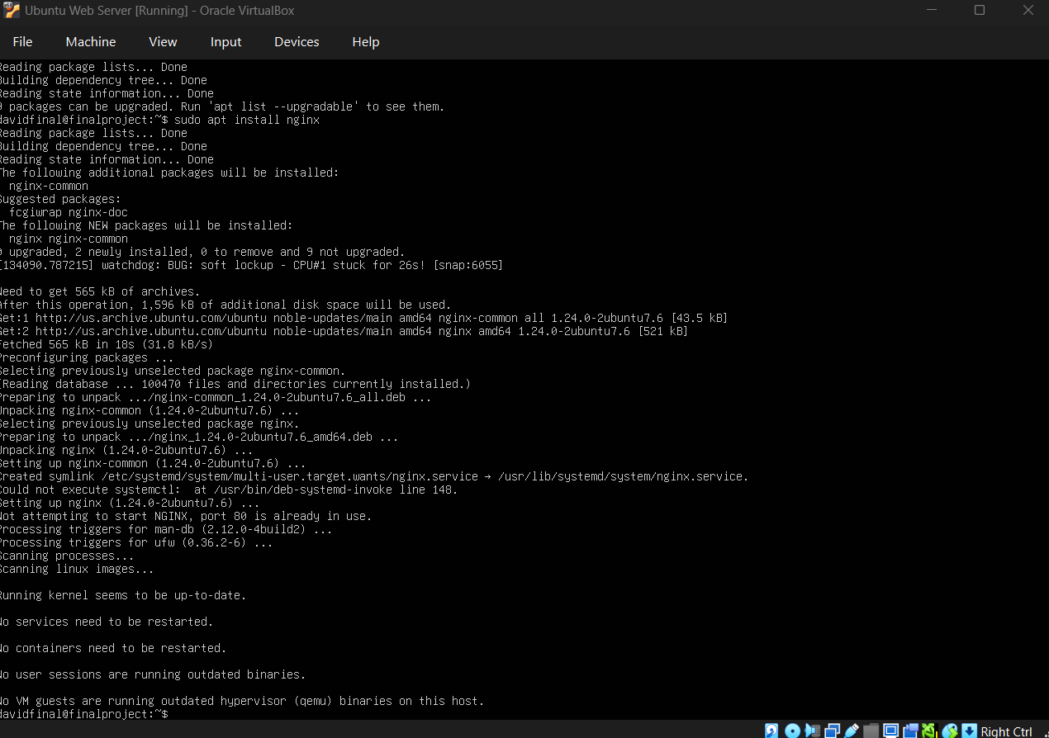
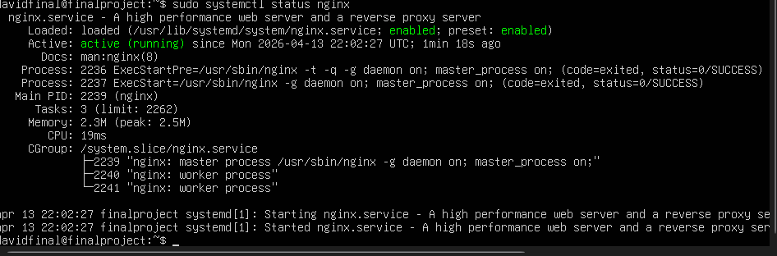

Setup for Nginx
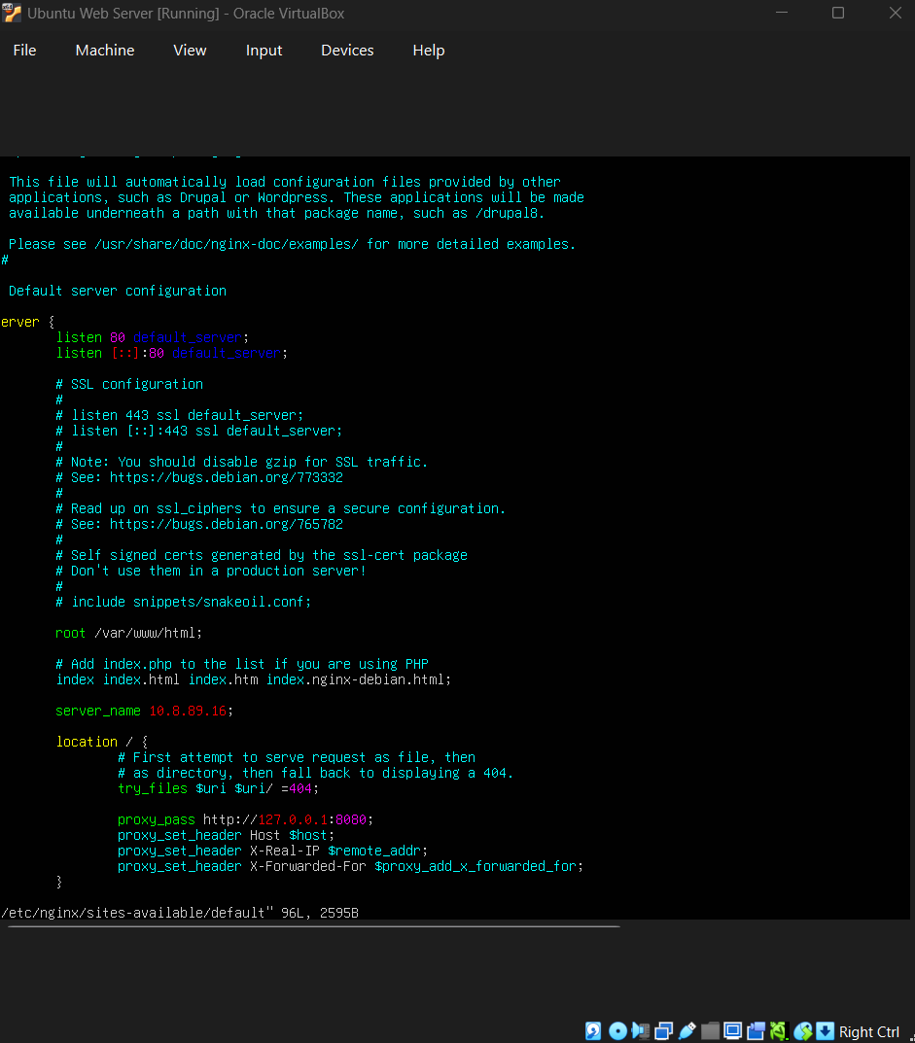

Changed Apache2 port (so that it works with nginx):
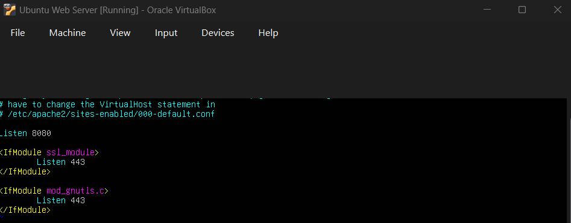
Apache2 status:
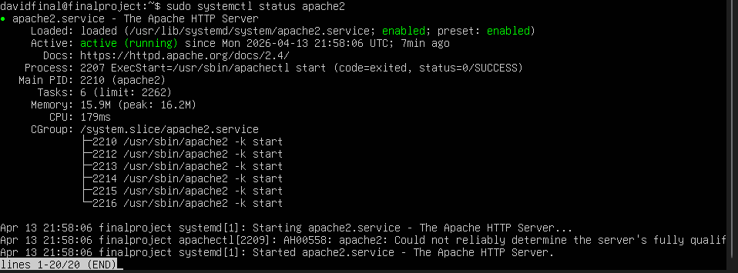
Ufw install and setup:
